PENETRATION TESTING LAB REPORT

Reflected XSS into HTML Attribute
PortSwigger Web Security Academy | Apprentice Lab

1. Executive Summary
A reflected Cross-Site Scripting (XSS) vulnerability was demonstrated in the PortSwigger Web Security Academy lab, “Reflected XSS into attribute with angle brackets HTML-encoded.” The search functionality reflected user-controlled input inside a quoted HTML attribute. Although angle brackets were HTML-encoded, the attribute context could still be escaped and an event-handler attribute injected. JavaScript execution was confirmed by a browser alert, and PortSwigger displayed the lab completion banner.

2. Lab Information and Scope
Platform: PortSwigger Web Security Academy
Lab: Reflected XSS into attribute with angle brackets HTML-encoded
Vulnerability: Reflected Cross-Site Scripting (XSS)
Difficulty: Apprentice
Injection point: Search parameter
Context: Quoted HTML attribute
Scope: Assigned, intentionally vulnerable PortSwigger lab instance
Testing was restricted to the authorised training environment.

3. Vulnerability Overview
The application reflects the search input into a quoted HTML attribute. Angle brackets are HTML-encoded, preventing direct injection of ordinary HTML tags. However, if quotation marks are not safely handled, an attacker may terminate the existing attribute value and inject an event-handler attribute. When the event is triggered, the browser executes the injected JavaScript.

4. Methodology and Findings
- Opened the assigned PortSwigger lab and identified the blog search functionality.
- Submitted a test search term and inspected the request and response using Burp Suite.
- Observed that the search input was reflected inside a quoted HTML attribute. Angle brackets were HTML-encoded.
- Tested attribute injection by breaking out of the existing quoted attribute and adding an onmouseover event handler.
- Triggered the event in the browser and observed an alert displaying “1”.
- Confirmed that PortSwigger displayed the lab completion banner.

5. Proof of Concept
Parameter: search
Injection context: Quoted HTML attribute
Payload: "onmouseover="alert(1)
The payload closes the existing quoted attribute value and introduces an onmouseover event handler. The alert dialog is evidence of JavaScript execution. The completion screenshot confirms that the lab was solved.

6. Security Impact
Reflected XSS can allow an attacker to execute JavaScript in a victim's browser under the vulnerable site's origin if the victim is induced to visit a crafted URL or interact with the affected page. Depending on the application and browser protections, consequences may include page manipulation, phishing, access to information available to page scripts, or actions performed through a victim's authenticated session. The lab evidence confirms script execution but does not independently demonstrate each possible impact.

7. Remediation
- Apply context-sensitive output encoding to untrusted data placed in HTML attributes.
- Always quote attribute values and ensure user-controlled input cannot terminate the quoted value.
- Use secure templating frameworks with context-aware output encoding.
- Do not rely on HTML-encoding angle brackets alone; quotation marks and event-handler attributes must also be handled safely.
- Use a restrictive Content Security Policy as additional defence, not as a replacement for safe output handling.

8. Evidence
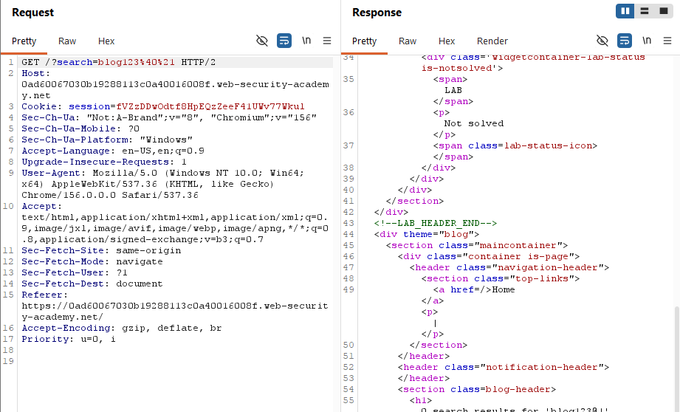
Figure 1. Burp Suite request and response inspection during testing of the search parameter.
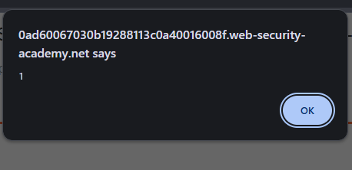
Figure 2. Browser alert displaying 1, confirming JavaScript execution.
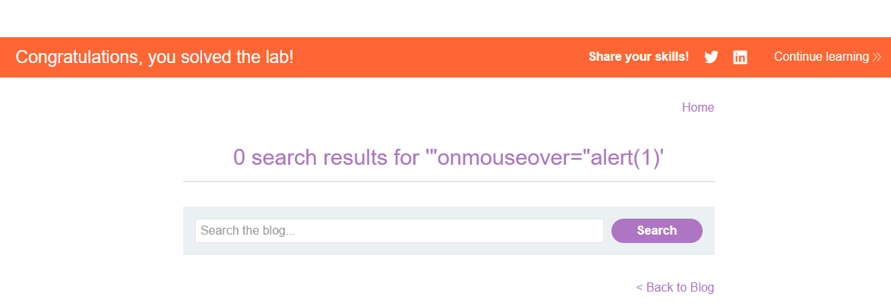
Figure 3. PortSwigger confirmation that the lab was solved; the reflected search term is visible in the results heading.

9. Conclusion
The lab demonstrated that HTML-encoding angle brackets alone is insufficient to prevent XSS when untrusted input is reflected into a quoted attribute. The injected event handler executed JavaScript, and the platform confirmed successful completion. Output handling must be appropriate to the exact HTML context, including attribute delimiters.

10. Limitations and Reporting Notes
This report documents a controlled training exercise, not a production-system assessment. The screenshots show Burp Suite inspection, a browser alert and the lab completion page. They do not provide a complete raw request/response pair showing every stage of the final exploit.
CVSS: Not assigned. A production severity score requires application-specific context and a justified impact assessment. CVE: None identified or applicable to this deliberately constructed lab.

